# Abstract

The aims of this investigation was to find the inductance of an inductor in an AC circuit (found to be (0.327 8x10-3)H), The capacitance of a capacitor in an AC circuit (found to be ($8.59±0.2$) $μF$) and the resonant frequency (found to be (74 $±$ 4)Hz) of an LRC circuit.

# Underlying Physics

Electromagnetism:

When a current flows through a wire, a magnetic field is induced perpendicular to the wire. By wrapping the wire into a coil and running current through it you can induce a magnetic field creating an electromagnet. The strength of the current determines the strength of the electromagnet. We can increase the strength by increasing the loops in the coil and by wrapping the coil around an iron core (BBC (n.d) *Electromagnets and motors)*.

Faraday’s Law:

When a magnetic field changes by getting stronger; weaker; rotating or moving relative to a coil of wire, a voltage (Emf (Electromotive Force)) is induced in the coil. Faraday’s law describes the relationship between the electromotive, the rate of change of the magnetic flux (total magnetic field in a given area (Julie Boyle, Chad Harrison (n.d) *Glossary)*) ($\frac{Δϕ}{Δt}$) and the number of turns/wraps in the coil:

$Emf=-N\frac{Δϕ}{Δt}$

Where:

Emf is the generated electromotive force (V)

$N$ is the number of loops in the coil (No units)

$\frac{Δϕ}{Δt}$ is the rate of change of the magnetic flux (the change of the magnetic field over the change of time) (Tm2s-1)

is the magnetic field (the one changing) (T)

$A$ is the area of the coil (m2)

(Carl R. Nave (n.d) *Faraday's Law)*

Lenz’s Law:

When an emf is produced due to a changing magnetic flux it also produces a current. This current generates a magnetic field as it flows through a coil of wire and thus it becomes an electromagnet. This magnetic field will oppose the change in the magnetic flux that produced the emf and current. This means the induced magnetic field will always ‘try’ to keep the magnetic flux constant. This is known as Lenz’s Law. (Carl R. Nave (n.d) *Lenz's Law)*

Alternating Current:

An alternating current (AC) is one that is constantly changing polarity (direction), when the current is plotted over time the current forms a sine wave, meaning it has frequency and amplitude like any other wave. The effect of AC is to have a lower average current and voltage, referred to as the rms current and rms voltage, and that the current is constantly changing.

The voltage and current of AC at any point in time can be calculated using:

$V=V_{m}\sin{ωt}$ (AspenCore (n.d) *Sidusoidal Waveforms)*

$$I=I_{m}\sin{ωt}$$

Where:

$V$ is the current voltage (V)

$I$ is the current voltage (A)

$V_{m}$ is the maximum voltage (V)

$I_{m}$ is the maximum voltage (A)

$ω$ is the angular frequency of the Alternating Current (rads-1)

is the time (s)

Phase:

In an AC circuit both the current and voltage have their own sine wave, phase difference is the difference between the peaks of these to waves, for example some components cause the voltage to ‘lag’ a small amount meaning the peaks of each wave do not occur at the same time. The phase difference is the time difference between the peaks divided by the period of the waves and is measured in degrees. The phase difference is always less than or equal to 90 degrees and refers to the angle by which the voltage leas the current (if the current lags the voltage the phase difference is positive, if the voltage lags the current the phase difference is negative). (Carl R. Nave (n.d) *Phase)*

Inductors:

An inductor is a coil of wire that opposes the change of current flowing through it, a perfect inductor has no resistance. This occurs as the current flowing through the coil produces a magnetic field. When the current changes so does the magnetic field and the change in this magnetic field induces an emf. This is in the opposite direction to the change in current and is known as back emf.

$$ε=-L\frac{ⅆI}{ⅆt}$$

Where:

$ε$ is the back emf (V)

$L$ is the inductance (H)

$\frac{ⅆI}{ⅆt}$ is the rate of change of the current (As-1)

(Carl R. Nave (n.d) *Inductors)*

A 1H inductor is one that gives 1V of back emf when there is a rate of change in the current of 1As-1. Note: When there is no change in current, there is no back emf produced.

Inductors in AC circuits:

In a sinusoidal AC circuit, the current is constantly changing, this means an inductor will constantly be producing a back emf. The back emf is dependent on the frequency of the AC circuit, this effect is known as inductive reactance. The inductive reactance is equal to the maximum voltage over the minimum current:

$$X_{L}=\frac{v_{m}}{I_{m}}$$

Where:

$X_{L}$ is the inductive reactance ($Ω$)

$v_{m}$ is the maximum voltage (V)

$I_{m}$ is the maximum current (A)

(Carl R. Nave (n.d) *Inductor AC Response)*

But the inductive reactance is dependent on the frequency of the current, the equation to find the inductive reactance using frequency can be derived as so:

$$V=V_{m}\sin{ωt} ε=L\frac{ⅆI}{ⅆt}$$

$$ε=v L\frac{ⅆI}{ⅆt}= V_{m}\sin{ωt}$$

$$dI=\frac{V_{m}}{L}\sin{ωtⅆt} ∫dI=∫\frac{V_{m}}{L}\sin{ωtⅆt}$$

$$I=\frac{V_{m}}{ωL}\left(-\cos{ωt}\right) I=\frac{V_{m}}{ωL}\sin\left(ωt-\frac{π}{2}\right)$$

At $ωt= π$ $\sin\left(ωt-\frac{π}{2}\right)=1$

∴ $I_{m}=\frac{V_{m}}{ωL}$

$$ωL=\frac{V_{m}}{I_{m}} ω=2πf$$

$$X_{L}=\frac{V_{m}}{I_{m}}=2πfL$$

$$X_{L}∝f$$

Where:

$V$ is the voltage of the AC input (V)

$V_{m}$ is the maximum voltage (V)

$I_{m}$ is the maximum current (A)

$ω$ is the angular frequency of the Alternating Current (rads-1)

is the current point in time (s)

$ε$ is the back current (emf) (V)

$L$ is the inductance (H)

$\frac{ⅆI}{ⅆt}$ is the rate of change of the current (As-1)

is the frequency of the supply (Hz)

$X_{L}$ is the inductive reactance ($Ω$)

(Mechatrofice (2/2/2017) *Inductive Reactance Formula Derivation)*

In an AC circuit an inductor makes the current lag the voltage producing a phase difference of 90o. (Carl R. Nave (n.d) *Inductor AC Response)*

Capacitors:

A capacitor is a pair of parallel plates with an insulator between them. A capacitor can be used to store charge. The maximum charge that can be stored on a capacitor is directly proportional to the voltage across it:

$$Q=CV$$

Where:

$Q$ is the charge the capacitor can store (C)

$C$ is the capacitance of the capacitor (F)

$V$ is the voltage across the capacitor (V)

(Carl R. Nave (n.d) *Capacitors)*

Charge can flow onto but not through a capacitor (as the plates are insulated from each other). As charge builds up on one plate, it repels charge from the other creating an effective flow of charge. Initially little energy is required to add charge to a capacitor but as the charge stored on the capacitor builds, more energy is required to add more charge and so the rate at which charge is added decreases as charge is added. When the energy required to add more charge is greater than the energy each charge has (the supply voltage) no more charge can be added and so the current stops. At that point, the voltage across the capacitor will be equal to the supply voltage. This process looks like:

Charging:

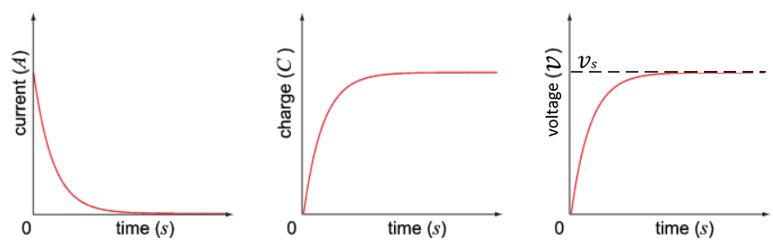

(Julie Boyle, Chad Harrison (n.d) Charging and *Discharging Capacitors in D.C. Circuits)*

At this point, one of the plates is saturated with charges and the other is deficient. This means when discharging the capacitor the charges will flow from the saturated plate to the deficient one. This is in the opposite direction to the current that originally charged the capacitor. The current starts at its maximum value and decreases to 0A as the charges leave the saturated plate, the rate at which the charges leave the saturated plate decreases as the charge is lost. The voltage also starts at its maximum value and decreases to 0V as the charge difference between the two plates decreases. This process looks like:

Discharging:

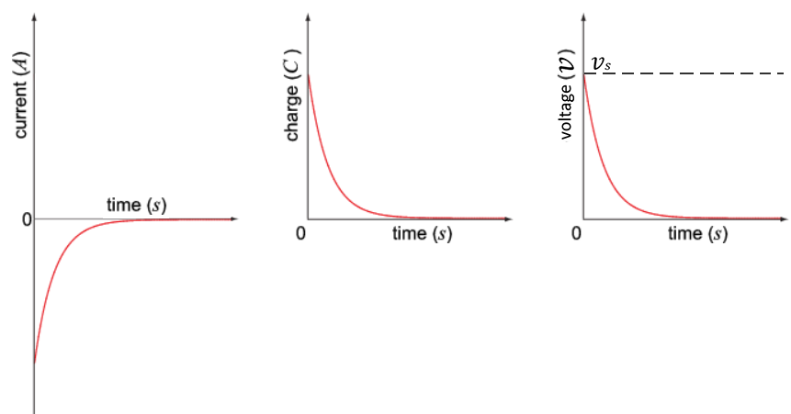

(Julie Boyle, Chad Harrison (n.d) *Discharging a Capacitor)*

When a capacitor is discharging through resistor the voltage over the capacitor and the voltage over the resistor add to 0, using this fact we can find an equation to find the voltage across the capacitor at any point in time:

$$V_{c}+V_{R}=0 V_{c}=-V_{R}$$

$${ V}_{c}=-IR V_{c}=-\frac{ⅆQ}{dt}R$$

$${ V}_{c}=-\frac{ⅆ\left(CV\right)}{ⅆt}R C is constant$$

$${ V}_{c}=-CR\frac{ⅆV}{ⅆt} \frac{ⅆV}{ⅆt}=-\frac{V_{c}}{CR}$$

$$\frac{ⅆV}{V_{C}}=-\frac{1}{RC}ⅆt$$

Integrate both sides:

$$∫\frac{1}{V_{c}}ⅆV=\frac{1}{RC}∫ⅆt \ln{V_{C}}=-\frac{t}{RC}+k$$

At t=0, $V_{C}=V_{0}$ So $\ln{V_{C}}= \ln{V_{0}}$ and therefore $k=\ln{V_{0}}$

$$\ln{V_{c}}=-\frac{t}{RC}+\ln{V_{0}} take the exponent of both sides$$

$$V_{C}=ⅇ^{\left(-\frac{t}{RC}+\ln{V_{0}}\right)}=ⅇ^{-\frac{t}{RC}}×ⅇ^{\ln{V_{0}}}$$

$$V_{c}=V_{0}ⅇ^{-\frac{t}{RC}}$$

Where:

$V_{c}$ is the voltage across the capacitor (V)

$V_{R}$ is the voltage across the resistor (V)

$V_{0}$ is the initial voltage (V)

$I$ is the current (A)

$R$ is the resistance of the resistor (Ω)

$\frac{ⅆQ}{dt}$ is the rate of change of charge ( $Q$ is charge (C)) (Cs-1)

is the capacitance of the capacitor (F)

$t$ is time (s)

This equation shows us that that the voltage across a capacitor decays exponentially.

The same is true for the current and charge, the equations are also similar:

$$I=I_{0}ⅇ^{-\frac{t}{RC}}$$

$$Q=Q_{0}ⅇ^{-\frac{t}{RC}}$$

Where:

$I$ is the current (A)

$I_{0}$ is the initial current (A)

$Q$ is the charge (C)

$Q_{0}$ is the initial charge (C)

The same can be done for when a capacitor is charging through a resistor, in that case the equations are:

The equation for current does not change as the current is still decreasing exponentially

$$I=I_{0}ⅇ^{-\frac{t}{RC}}$$

The equations for charge and voltage invert as they are increasing at an exponentially decreasing rate:

$$Q=Q_{0}\left(1-ⅇ^{-\frac{t}{RC}}\right)$$

$$V=V_{0}\left(1-ⅇ^{\frac{t}{RC}}\right)$$

$RC$ is known as the time constant of the circuit and is represented with the symbol $τ$

(Andrew McGuigan (2015) *Cfe Advanced Higher Physics)*

Capacitors in AC circuits:

In a sinusoidal AC circuit, the current is constantly changing, this means a capacitor will constantly be charging and discharging. As while the capacitor charges/discharges it causes the current to decrease this has the effect of opposing the change in current. The opposition to the change in current is dependent on the frequency of the AC circuit, this effect is known as capacitive reactance. The capacitive reactance is equal to the maximum voltage over the minimum current:

$$X_{C}=\frac{v_{m}}{I_{m}}$$

Where:

$X_{C}$ is the inductive reactance ($Ω$)

$v_{m}$ is the maximum voltage (V)

$I_{m}$ is the maximum current (A)

(Julie Boyle, Chad Harrison (n.d) *Capacitors In A.C. Circuits)*

But the capacitive reactance is dependent on the frequency of the current, the equation to find the capacitive reactance using frequency can be derived as so:

$$V=V_{m}\sin{ωt} Q=CV$$

$$Q=CV_{m}\sin{ωt} I=\frac{ⅆQ}{dt}$$

$$I=\frac{ⅆ}{dt}CV_{m}\sin{ωt}=ωCV_{m}\cos{ωt}$$

$$I=ωCV_{m}\sin\left(ωt+\frac{π}{2}\right)$$

At $t=0 \sin\left(ωt+\frac{π}{2}\right)=1$

∴ $I_{m}=ωCV_{m} \frac{V_{m}}{I_{m}}=\frac{1}{ωC}$

$$ω=2πf$$

$$X_{C}=\frac{v_{m}}{I_{m}}=\frac{1}{2πfC}$$

$$X_{c}∝\frac{1}{f}$$

Where:

$V$ is the current voltage(V)

$V_{m}$ is the maximum voltage (V)

$ω$ is the angular frequency of the Alternating Current (rads-1)

is the current point in time (s)

$Q$ is the charge the capacitor can store (C)

$C$ is the capacitance of the capacitor (F)

$V$ is the voltage across the capacitor (V)

$I$ is the current (A)

$I_{m}$ is the maximum current (A)

$f$ is the frequency of the AC supply (Hz)

$X_{C}$ is the capacitive reactance (Ω)

(Mechatrofice (2/2/2017) *Capacitive Reactance Formula Derivation)*

In an AC circuit a capacitor makes the current lead the voltage producing a phase difference of -90o. (Carl R. Nave (n.d) *Capacitor AC Response)*

RLC series circuits:

An RLC circuit is a circuit consisting of a resistor, inductor and capacitor in series. When an RLC circuit is ‘hooked up to’ an AC supply the RLC circuit will limit the flow of current:

$$I=\frac{V}{\sqrt{R^{2}+{\left(X_{L}-X_{c}\right)}^{2}}}$$

The reactances subtract as they have a phase difference of 180o, as capacitors make the current lead the voltage by 900 and inductors make the current lag the voltage by 900. This means the peaks and troughs of the current waves created match up.

Where:

$I$ is the current (A)

$V$ is the voltage (V)

$R$ is the resistance of the resister (Ω)

$X_{L}$ is the inductive reactance of the inductor (Ω)

$X_{c}$ is the capacitive reactance of the capacitor (Ω)

(Carl R. Nave (n.d) *RLC Series Impedance)*

As the inductive and capacitive reactance are both dependant on the frequency of the supply, the current is also dependant on the frequency of the supply. As $X_{L}∝f$ ($X_{L}$ is directly proportional to the frequency) and $X_{c}∝\frac{1}{f}$ ( $X_{c}$ is inversely proportional to the frequency), for a certain frequency $X_{c}$ will equal $X_{L}$ and they will cancel out. This results in the current only being limited by the resistor. The frequency at which this occurs is known as the resonant frequency and can be calculated using the inductance of the inductor and the capacitance of the capacitor:

$$ω=\frac{1}{\sqrt{LC}} ω=2πf$$

$$2πf=\frac{1}{\sqrt{LC}} f=\frac{1}{2π\sqrt{LC}}$$

Where

$ω$ is the angular frequency of the Alternating Current (rads-1)

is the inductance of the inductor (H)

$C$ is the capacitance of the capacitor (F)

$f$ is the frequency of the supply (Hz)

(Carl R. Nave (n.d) *Resonance)*

# Procedures

Experiment 1 – Inductor in an AC circuit:

Apparatus:

* A signal generator 4.5kHz to 1.5kHz (not digital)
* A digital oscilloscope
* A voltmeter (multimeter)
* An ammeter (second multimeter)
* A 0.5H Inductor

Method:

Setup:

* The inductor and ammeter were set up in series with the signal generator as the supply.
* The voltmeter was then set up in parallel to the signal generator to measure the supply voltage.
* The oscilloscope was also set up in parallel to the signal generator to double check the frequency of the supply.

Circuit Diagram:

AC supply

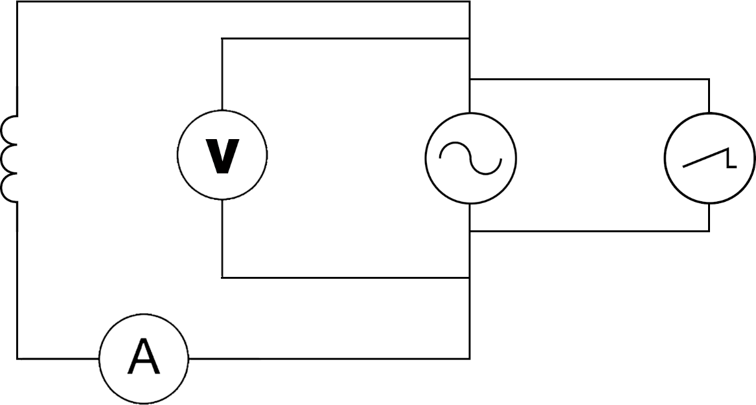

Inductor

Ammeter

Voltmeter

Oscilloscope

Procedure:

The signal generator was set to a frequency which is checked using the numerical value provided by the oscilloscope. The voltage was adjusted to 5V with a voltmeter across the supply. The current was measured with an ammeter in series with the inductor. The signal generator was switched off and on again 5 times to get repeat readings. The frequency was then lowered by 0.5kHz and repeated. The range of frequencies measured were from 4.5kHz to 1.5kHz.

Experiment 2 – Capacitor in an AC circuit:

Apparatus:

* A digital signal generator 1kHz to 100Hz
* A digital oscilloscope
* A voltmeter (multimeter)
* An ammeter (second multimeter)
* A 10 $μF$ mylar Capacitor

Method:

Setup:

* The capacitor and ammeter were set up in series with the signal generator as the supply.
* The voltmeter was then set up in parallel to the signal generator to measure the supply voltage.
* The oscilloscope was also set up in parallel to the signal generator to double check the frequency of the supply.

Circuit Diagram:

AC supply

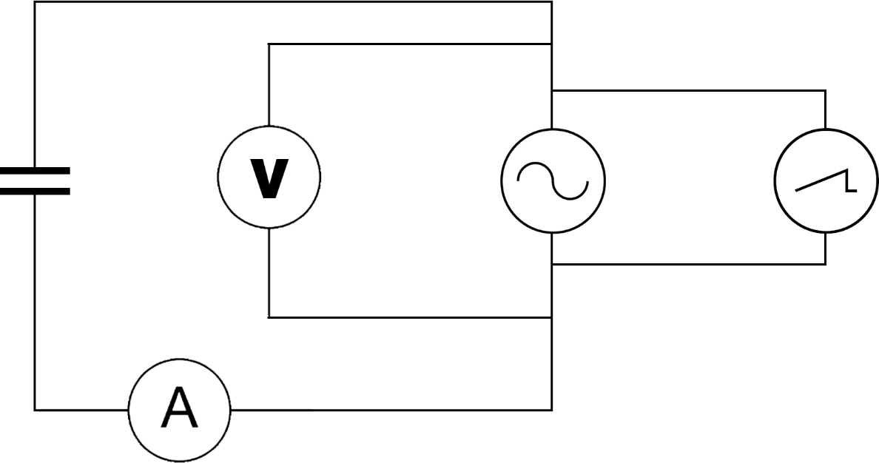

Capacitor

Ammeter

Voltmeter

Oscilloscope

Procedure:

The signal generator was set to a frequency which is checked using the numerical value provided by the oscilloscope. The voltage was adjusted to be 5V with a voltmeter across the supply. The current was measured with an ammeter in series with the capacitor. The signal generator was switched off and on again 5 times to get repeat readings. The frequency was then lowered by 100Hz and repeated. The range of frequencies measured were from 1kHz to 100Hz.

Experiment 3 – AC current in an RLC circuit:

Apparatus:

* A digital signal generator 10Hz to 130Hz
* A digital oscilloscope
* A voltmeter (multimeter)
* An ammeter (second multimeter)
* A 10 $μF$ Mylar Capacitor
* A 0.5H Inductor
* A 100Ω Resistor

Method:

Setup:

* The resistor, capacitor, inductor and ammeter were set up in series with the signal generator as the supply.
* The voltmeter was then set up in parallel to the signal generator to measure the supply voltage.
* The oscilloscope was also set up in parallel to the signal generator to double check the frequency of the supply.

Circuit Diagram:

Capacitor

AC supply

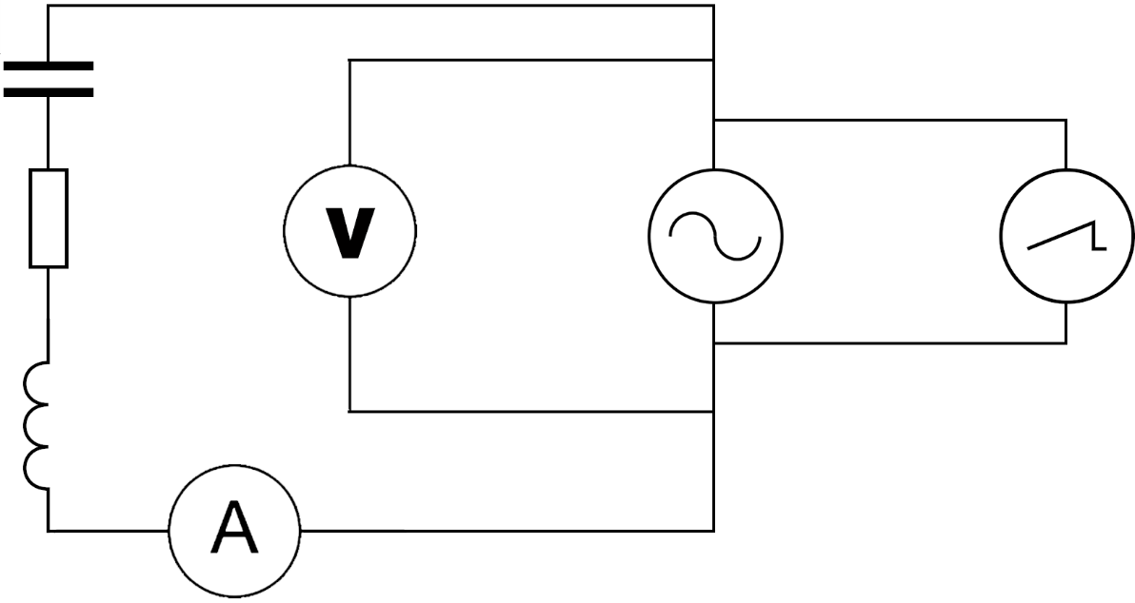

Inductor

Ammeter

Resistor

Oscilloscope

Voltmeter

Procedure:

The signal generator was set to a frequency which is checked using the numerical value provided by the oscilloscope. The voltage was adjusted to 5V with a voltmeter across the supply. The current was measured with an ammeter in series with the inductor, capacitor and resistor. The signal generator was switched off and on again 5 times to get repeat readings. The frequency was then increased by 10Hz and repeated. The range of frequencies measured were from 10Hz to 130Hz.

# Results

Experiment 1 – Inductor in an AC circuit:

Results:

|  |  |  |  |  |  |  |  |  |  |  |  |  |
| --- | --- | --- | --- | --- | --- | --- | --- | --- | --- | --- | --- | --- |
|  | | |  |  | | Current (mA) | |  | |  | |  |
| Frequency (kHz) | | 1/F (s) | Voltage (V) | | 1 | 2 | 3 | 4 | | 5 | | avg |  | |
| 4.5 | | 0.0002222 | 5 | | 0.442 | 0.444 | 0.444 | 0.445 | | 0.445 | | 0.444 |  | |
| 4.0 | | 0.0002500 | 5 | | 0.527 | 0.526 | 0.525 | 0.525 | | 0.525 | | 0.526 |  | |
| 3.5 | | 0.0002857 | 5 | | 0.623 | 0.622 | 0.622 | 0.622 | | 0.622 | | 0.622 |  | |
| 3.0 | | 0.0003333 | 5 | | 0.752 | 0.749 | 0.75 | 0.749 | | 0.749 | | 0.750 |  | |
| 2.5 | | 0.0004000 | 5 | | 0.921 | 0.918 | 0.917 | 0.916 | | 0.917 | | 0.918 |  | |
| 2.0 | | 0.0005000 | 5 | | 1.152 | 1.151 | 1.150 | 1.150 | | 1.150 | | 1.151 |  | |
| 1.5 | | 0.0006667 | 5 | | 1.531 | 1.529 | 1.530 | 1.527 | | 1.529 | | 1.529 |  | |

Uncertainties:

Current uncertainties (mA):

|  |  |  |  |  |  |
| --- | --- | --- | --- | --- | --- |
| averages | Δcal | Δread | Δrand | Δtotal | Δ% |
| 0.444 | 0.0222 | 0.001 | 0.0006 | 0.0222 | 5 |
| 0.526 | 0.02628 | 0.001 | 0.0004 | 0.02628 | 5 |
| 0.622 | 0.03111 | 0.001 | 0.0002 | 0.03111 | 5 |
| 0.750 | 0.03749 | 0.001 | 0.0006 | 0.03749 | 5 |
| 0.918 | 0.04589 | 0.001 | 0.001 | 0.04589 | 5 |
| 1.151 | 0.05753 | 0.001 | 0.0004 | 0.05753 | 5 |
| 1.529 | 0.07646 | 0.001 | 0.0008 | 0.07646 | 5 |

These were calculated using the results gathered:

Δcal: this was 5% of the average, this was found in the instruction manual for the multimeter used.

Δread: As the multimeter used to read the current was digital this is the smallest decimal place the multimeter can read.

Δrand: This was calculated using the results gathered: (the greatest reading – the lowest reading) / the number of readings.

Δtotal = Δcal (as the Δread and Δrand were ignored because they are both always less than a third of Δcal)

Δ%: (Δtotal/the average)*100

Frequency uncertainties (Hz):

Δcal was 1x10-2

Which is so small it is negligible.

Δread = 0.001

Which is also so small it is negligible.

Δtotal = N/A

Voltage uncertainties (V):

∆cal = 0.8% + 3 of the least sig figs = 0.07 (0.04 + 0.03)

Δread = 0.01

Δtotal = 0.071

∆% = 1.42%

Graph:

gradient = 2.432703936As-1

intercept = -7.52532x10-5A

∆ gradient = 0.044827As-1

%∆ gradient = 1.842698475 $=$ 1.84%

These values were obtained using the LINEST function in the excel file results were recorded in.

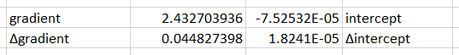

A

A

As-1

As-1

Calculations:

|  |  |
| --- | --- |
| This equation can be put in the form of thestraight line formula:  represents , represents  and represents  the gradient from the graph = =  Using the value of the voltage measured and the value of the gradient from the graph found using the LINEST function. $$=0.32711$$ $$=0.327H$$ | $$ΔL=\sqrt{{\left(\%Δm\right)}^{2}+{\left(\%ΔV\right)}^{2}}$$ $$=\sqrt{{1.84}^{2}{+1.42}^{2}}$$ $=\sqrt{5.402}$ $=2.3242202$ $=2.32\%$ $$ΔL=0.0075864$$ $${=8×10}^{-3}H$$ |

Conclusion:

The average inductance of the inductor was (0.3278x10-3) H over a range of 4.5-1.5kHz

Experiment 2 – Capacitor in an AC circuit

Results:

|  |  |  |  |  |  |  |  |  |  |  |  |
| --- | --- | --- | --- | --- | --- | --- | --- | --- | --- | --- | --- |
|  | |  | | Current (A) | |  | |  | |  |  |
| Frequency (Hz) | Voltage (V) | 1 | 2 | | 3 | | 4 | | 5 | avg |
| 1000 | 5 | 0.267 | 0.268 | | 0.268 | | 0.268 | | 0.268 | 0.268 |
| 900 | 5 | 0.239 | 0.240 | | 0.240 | | 0.239 | | 0.239 | 0.239 |
| 800 | 5 | 0.212 | 0.213 | | 0.213 | | 0.213 | | 0.212 | 0.213 |
| 700 | 5 | 0.186 | 0.186 | | 0.186 | | 0.186 | | 0.186 | 0.186 |
| 600 | 5 | 0.159 | 0.159 | | 0.159 | | 0.159 | | 0.159 | 0.159 |
| 500 | 5 | 0.132 | 0.133 | | 0.133 | | 0.133 | | 0.133 | 0.133 |
| 400 | 5 | 0.106 | 0.106 | | 0.106 | | 0.106 | | 0.106 | 0.106 |
| 300 | 5 | 0.0800 | 0.0800 | | 0.0800 | | 0.0800 | | 0.0800 | 0.0800 |
| 200 | 5 | 0.0530 | 0.0530 | | 0.0530 | | 0.0530 | | 0.0530 | 0.0530 |
| 100 | 5 | 0.0270 | 0.0270 | | 0.0270 | | 0.0270 | | 0.0270 | 0.0270 |

Uncertainties:

Current uncertainties (A):

|  |  |  |  |  |  |
| --- | --- | --- | --- | --- | --- |
| averages | Δcal | Δread | Δrand | Δtotal | Δ% |
| 0.268 | 0.0134 | 0.001 | 0.0002 | 0.0134 | 5 |
| 0.239 | 0.0120 | 0.001 | 0.0002 | 0.0120 | 5 |
| 0.213 | 0.0106 | 0.001 | 0.0002 | 0.0106 | 5 |
| 0.186 | 0.00930 | 0.001 | 0 | 0.00930 | 5 |
| 0.159 | 0.00795 | 0.001 | 0 | 0.00795 | 5 |
| 0.133 | 0.00664 | 0.001 | 0.0002 | 0.00664 | 5 |
| 0.106 | 0.00530 | 0.001 | 0 | 0.00530 | 5 |
| 0.0800 | 0.00400 | 0.001 | 0 | 0.00400 | 5 |
| 0.0530 | 0.00265 | 0.001 | 0 | 0.00283 | 5 |
| 0.0270 | 0.00135 | 0.001 | 0 | 0.00168 | 6 |

These were calculated using the results gathered:

Δcal: this was 5% of the average, this was found in the instruction manual for the multimeter used.

Δread: As the multimeter used to read the current was digital this is the smallest decimal place the multimeter can read.

Δrand: This was calculated using the results gathered: (the greatest reading – the lowest reading) / the number of readings.

Δtotal = Δcal (Δrand This was ignored as it is always less than a third of Δcal) (Δread was sometimes grater than a third of Δcal, in these cases Δtotal = $\sqrt{{\left(Δcal\right)}^{2}+{\left(Δread\right)}^{2}}$)

∆%: (Δtotal/the average)*100

Voltage uncertainties (V):

∆cal = 0.8% + 3 of the least sig figs = 0.07 (0.04 + 0.03)

Δread = 0.01

Δtotal = 0.071

∆% = 1.42%

Frequency uncertainties (Hz):

Δcal was 1x10-2

Which is so small it is negligible.

Δread = 0.001

Which is also so small it is negligible.

Δtotal = N/A

Graph:

gradient = 0.00027As

intercept = -0.000347A

∆ gradient = 7.4x10-7As

%∆ gradient = 0.278145322 $=$ 0.28%

These values were obtained using the LINEST function in the excel file results were recorded in.

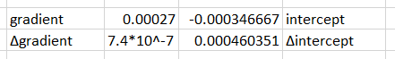

A

A

As

As

Calculations:

|  |  |
| --- | --- |
| $$X_{C}=\frac{V}{I}=\frac{1}{2πfC}$$ $$I∝f$$ $$I=2πCVf$$ This equation can be put in the form of the straight line formula: $$y=mx+C$$ $y$ represents $I$, $x$ represents $f$ and $m$ represents  the gradient from the graph =  Using the value of the voltage measured and the value of the gradient from the graph found using the LINEST function. $$=8.5943×{10}^{-6}$$ $$=8.59 μF$$ | $ΔC=\%ΔV$ (as $\%Δm$ is less than a third of $\%ΔV$) $=1.42\%$ $$ΔC=1.220×{10}^{-7}$$ $$=0.122 μF$$ $=0.2 μF$ rounding up because the uncertainty is greater than 0.1 |

Conclusion:

The average inductance of the inductor was ($8.59±0.2$) $μF$.

Experiment 3 – AC current in an RLC circuit:

Results:

|  |  |  |  |  |  |  |  |
| --- | --- | --- | --- | --- | --- | --- | --- |
|  |  |  |  | current(mA) |  |  |  |
| Frequency (Hz) | Voltage (V) | 1 | 2 | 3 | 4 | 5 | avg |
| 10 | 5 | 2.87 | 2.90 | 2.86 | 2.88 | 2.89 | 2.88 |
| 20 | 5 | 6.00 | 6.01 | 6.02 | 5.99 | 6.01 | 6.01 |
| 30 | 5 | 9.46 | 9.47 | 9.47 | 9.46 | 9.45 | 9.46 |
| 40 | 5 | 14.1 | 14.1 | 14.1 | 14.1 | 14.1 | 14.1 |
| 50 | 5 | 20.5 | 20.8 | 20.7 | 20.4 | 20.6 | 20.6 |
| 60 | 5 | 29.2 | 29.2 | 29.1 | 29.3 | 29.2 | 29.2 |
| 70 | 5 | 37.1 | 37.3 | 37.4 | 37.6 | 37.5 | 37.4 |
| 80 | 5 | 37.4 | 37.2 | 37.3 | 37.3 | 37.3 | 37.3 |
| 90 | 5 | 32.7 | 32.8 | 32.7 | 32.8 | 32.7 | 32.7 |
| 100 | 5 | 27.9 | 27.8 | 27.8 | 27.9 | 27.8 | 27.8 |
| 110 | 5 | 23.5 | 23.6 | 23.5 | 23.6 | 23.6 | 23.6 |
| 120 | 5 | 20.7 | 20.7 | 20.7 | 20.7 | 20.8 | 20.7 |
| 130 | 5 | 18.6 | 18.7 | 18.8 | 18.7 | 18.7 | 18.7 |

Uncertainties:

Current uncertainties (A):

|  |  |  |  |  |  |
| --- | --- | --- | --- | --- | --- |
| avg | ∆cal | ∆read | ∆rand | ∆total | ∆% |
| 2.88 | 0.144 | 0.01 | 0.008 | 0.144 | 5 |
| 6.01 | 0.300 | 0.01 | 0.006 | 0.300 | 5 |
| 9.46 | 0.473 | 0.01 | 0.004 | 0.473 | 5 |
| 14.1 | 0.704 | 0.01 | 0.01 | 0.704 | 5 |
| 20.6 | 1.03 | 0.1 | 0.08 | 1.03 | 5 |
| 29.2 | 1.46 | 0.1 | 0.04 | 1.46 | 5 |
| 37.4 | 1.87 | 0.1 | 0.1 | 1.87 | 5 |
| 37.3 | 1.87 | 0.1 | 0.04 | 1.87 | 5 |
| 32.7 | 1.64 | 0.1 | 0.02 | 1.64 | 5 |
| 27.8 | 1.39 | 0.1 | 0.02 | 1.39 | 5 |
| 23.6 | 1.18 | 0.1 | 0.02 | 1.18 | 5 |
| 20.7 | 1.04 | 0.1 | 0.02 | 1.04 | 5 |
| 18.7 | 0.935 | 0.1 | 0.04 | 0.935 | 5 |

These were calculated using the results gathered:

Δcal: this was 5% of the average, this was found in the instruction manual for the multimeter used.

Δread: As the multimeter used to read the current was digital this is the smallest unit the multimeter can read.

Δrand: This was calculated using the results gathered: (the greatest reading – the lowest reading) / the number of readings.

Δtotal: Δtotal = Δcal (as the Δread and Δrand were ignored because they are both always less than a third of Δcal)

∆%: (Δtotal/the average)*100

Frequency uncertainties (Hz):

Δcal was 1x10-2

Which is so small it is negligible.

Δread = 0.001

Which is also so small it is negligible.

Δtotal = N/A

Voltage uncertainties (V):

∆cal = 0.8% + 3 of the least sig figs = 0.07 (0.04 + 0.03)

Δread = 0.01

Δtotal = 0.071

∆% = 1.42%

Graph:

The theoretical values were calculated using:

Where:

$I$ is the current (A)

$V$ is the voltage (V)

$R$ is the resistance of the resister (Ω)

$X_{L}$ is the inductive reactance of the inductor (Ω)

$X_{c}$ is the capacitive reactance of the capacitor (Ω)

$$X_{L}=2πfL$$

Where:

$X_{L}$ is the inductive reactance ($Ω$)

$f$ is the frequency of the supply (Hz)

$L$ is the inductance (H)

$$X_{C}=\frac{1}{2πfC}$$

Where:

$X_{C}$ is the capacitive reactance (Ω)

$f$ is the frequency of the AC supply (Hz)

$C$ is the capacitance of the capacitor (F)

|  |
| --- |
| $$I=\frac{V}{\sqrt{R^{2}+{\left(X_{L}-X_{c}\right)}^{2}}}$$ $$I=\frac{V}{\sqrt{R^{2}+{\left(2πfL-\frac{1}{2πfC}\right)}^{2}}}$$ $$I=\frac{5}{\sqrt{{104}^{2}+{\left(2πf×0.5-\frac{1}{2πf×1{×10}^{-5}}\right)}^{2}}}$$ (Resistance is 104Ω as the resistor used was 100Ω and the inductor used had a resistance of 4Ω) |

The theoretical values have a different uncertainty for each value, calculated using:

$$\%ΔI_{t}=\sqrt{\%ΔV^{2}+{\left(\frac{1}{2}\left(\frac{\sqrt{{\left(\left(2×\frac{\%ΔR}{100}\right)×R\right)}^{2}+{\left(\left(2×\frac{\sqrt{{\left(2πfL×\frac{\%ΔL}{100}\right)}^{2}+{\left(\frac{1}{2πfC}×\frac{\%ΔC}{100}\right)}^{2}}}{\left(2πfL-\frac{1}{2πfC}\right)}\right)×\left(2πfL-\frac{1}{2πfC}\right)\right)}^{2}}}{\sqrt{R^{2}+{\left(2πfL-\frac{1}{2πfC}\right)}^{2}}}\right)×100\right)}^{2}}$$

(%∆ $f$ was not considered as the uncertainty was negligible)

Where:

$I$ is the current (A)

$V$ is the voltage (V)

$R$ is the resistance of the resister (Ω)

$f$ is the frequency of the supply (Hz)

$L$ is the inductance (H)

$C$ is the capacitance of the capacitor (F)

$\%ΔI_{t}$ is the percentage uncertainty in the theoretic values

$\%ΔV$ is the percentage uncertainty in the voltage

$\%ΔR$ is the percentage uncertainty in the resistance

$\%ΔL$ is the percentage uncertainty in the inductance

$\%ΔC$ is the percentage uncertainty in the capacitance

|  |
| --- |
| $$\%ΔI_{t}=\sqrt{\%ΔV^{2}+{\left(\frac{1}{2}\left(\frac{\sqrt{{\left(\left(2×\frac{\%ΔR}{100}\right)×R\right)}^{2}+{\left(\left(2×\frac{\sqrt{{\left(2πfL×\frac{\%ΔL}{100}\right)}^{2}+{\left(\frac{1}{2πfC}×\frac{\%ΔC}{100}\right)}^{2}}}{\left(2πfL-\frac{1}{2πfC}\right)}\right)×\left(2πfL-\frac{1}{2πfC}\right)\right)}^{2}}}{\sqrt{R^{2}+{\left(2πfL-\frac{1}{2πfC}\right)}^{2}}}\right)×100\right)}^{2}}$$ $$=\sqrt{{1.42}^{2}+{\left(\left(\frac{\sqrt{{\left(\left(2×\frac{1}{100}\right)×104\right)}^{2}+{\left(\left(2×\frac{\sqrt{{\left(2πf0.5×\frac{1}{100}\right)}^{2}+{\left(\frac{1}{2πf1×{10}^{-6}}×\frac{10}{100}\right)}^{2}}}{\left(2πf0.5-\frac{1}{2πf1×{10}^{-6}}\right)}\right)×\left(2πf0.5-\frac{1}{2πf1×{10}^{-6}}\right)\right)}^{2}}}{\sqrt{{104}^{2}+{\left(2πf0.5-\frac{1}{2πf1×{10}^{-6}}\right)}^{2}}}\right)×50\right)}^{2}}$$ $$=\sqrt{2.0164+{\left(\frac{50\sqrt{4.3264+{\left(\left(2×\frac{\sqrt{{\left(πf×\frac{1}{100}\right)}^{2}+{\left(\frac{1}{πf2×{10}^{-5}}\right)}^{2}}}{\left(πf-\frac{1}{πf2×{10}^{-6}}\right)}\right)×\left(πf-\frac{1}{πf2×{10}^{-6}}\right)\right)}^{2}}}{\sqrt{{104}^{2}+{\left(πf-\frac{1}{πf2×{10}^{-6}}\right)}^{2}}}\right)}^{2}}$$ $(\%ΔV$ was the value found earlier (calculated in the uncertainties section))  ( $\%ΔC$ was found using the markings on the capacitor, the uncertainty marking was the letter K indicating an uncertainty of $±$ 10%)  ( $\%ΔL$ and $\%ΔR$ were unknown and so calibration uncertainty advice was taken from the Learning And Teaching Scotland uncertainties guide ($±$ 1% was used)) |

The error bars of the theoretical values and the measured values overlap for almost all the data points explaining the difference between the two.

The resonant frequency of an RLC circuit is the frequency at which the highest current is measured. This is the frequency at which the turning/highest point on the graph occurs. As excel can’t fit a mathematical curve to this line, I can’t mathematically find the turning point and so I am estimating it by reading from the graph, I found this to be 74Hz. I am allowing an uncertainty of $±$ 4Hz as the area around the turning point is relatively flat and so I am not very confident in the exact location of the turning point.

Conclusion:

The resonant frequency of the RLC circuit is (74 $±$ 4) Hz.

# Evaluation

Experiment 1 – Inductor in an AC circuit:

For this experiment a standard method was used. This method has been used many times by scientists, for example as described in A Laboratory Manual of Physics by F Tyler, and can be considered reliable.

The use of a digital oscilloscope ensured that the frequencies used were accurate as it provided a numerical value for the frequency rather than requiring me to read the time intervals off the screen. For this experiment I used an old analogue signal generator which meant that consistently setting it to the desired frequency was quite tricky and it took some getting used to as the markings on it were not very accurate. The use of digital volt and ammeters ensured the readings of the voltage and current were accurate as they provide numerical values rather than present the value on a scale to be read. The readings at each frequency were taken 5 times to decrease the effect of any outlying readings and reduce the random uncertainty of the results. The voltmeter was used to ensure the voltage remained constant while I adjusted the frequency. To repeat the readings the AC source was switched off and back on, this was to try and ensure the frequency didn’t change too much between the repeats while still getting a new reading.

The range of frequencies over which the results were taken was too high, the range of frequencies I used was 4.5kHz to 1.5kHz but the given value of the inductance was 0.5H at 50Hz. This means that comparing my calculated value to the given value will be less effective. The value for the inductance I calculated was (0.3278x10-3)H, this is not very accurate as the uncertainty in the value does not cover the expected value (0.5Hz). This was expected as the range of frequencies over which the inductance was calculated was much greater than that it was ‘rated’ for and as the inductor used was quite old, meaning the given value for the inductance is not known with confidence.

Once the results had been graphed I noticed that the line of best fit did not pass through the origin as expected, the intercept was -7.52532x10-5A. This intercept falls under the uncertainty of on the gradient (0.044827As-1) therefore this discrepancy is encompassed in the uncertainties. The intercept could be due to unaccounted-for resistance in the circuit causing the current to be lower than expected for each frequency.

Experiment 2 – Capacitor in an AC circuit:

For this experiment a standard method was used. This method has been used many times by scientists, for example as described in A Laboratory Manual of Physics by F Tyler, and can be considered reliable.

The use of a digital oscilloscope ensured that the frequencies used were accurate as it provided a numerical value for the frequency rather than requiring me to read the time intervals off the screen. This time I used a digital signal generator which was much easier to use and was more accurate with its markings. The use of digital volt and ammeters ensured the readings of the voltage and current were accurate as they provide numerical values rather than present the value on a scale to be read. The readings at each frequency were taken 5 times to decrease the effect of any outlying readings and reduce the random uncertainty of the results. The voltmeter was used to ensure the voltage remained constant while I adjusted the frequency. To repeat the readings the AC source was switched off and back on, this was to try and ensure the frequency didn’t change too much between the repeats while still getting a new reading.

The range of frequencies over which the results were taken was adequate as it spanned from 100Hz – 1kHz providing a large interval for a trend to form over.

The value calculated for the capacitor was ($8.59±0.2$) $μF$. This is not very accurate as the uncertainty in the value does not cover the expected value ((10 $±1$) $μF$) even with the uncertainties in both values. This could be due to age the possibility the capacitor does not have the exact capacitance stated on it.

Once the results had been graphed the y-intercept of the line of best fit was found to be -0.000347A, this indicates a systematic error as the line of best fit should have passed through the origin. This intercept cannot be explained by the uncertainty in the gradient (∆gradient = 7.4x10-7As-1) as it is too large. This could be due to the unaccounted-for resistance in the circuit causing the current to be lower than expected for each frequency.

Experiment 3 – AC current in an RLC circuit:

For this experiment a standard method was used. This method has been used many times by scientists, for example as described in A Laboratory Manual of Physics by F Tyler, and can be considered reliable.

The use of a digital oscilloscope ensured that the frequencies used were accurate as it provided a numerical value for the frequency rather than requiring me to read the time intervals off the screen. A digital signal generator was used again to make setting the frequencies of the supply easier. The use of digital volt and ammeters ensured the readings of the voltage and current were accurate as they provide numerical values rather than present the value on a scale to be read. The readings at each frequency were taken 5 times to decrease the effect of any outlying readings and reduce the random uncertainty of the results. The voltmeter was used to ensure the voltage remained constant while I adjusted the frequency. To repeat the readings the AC source was switched off and back on. This was to try and ensure the frequency didn’t change too much between the repeats while still getting a new reading.

To determine the range over which the values were to be taken I calculated the expected resonant frequency:

|  |
| --- |
| $$f=\frac{1}{2π\sqrt{LC}}$$ $$=\frac{1}{2π\sqrt{0.5×1×{10}^{-5}}}$$ $$=71.17625…$$ $$≈71Hz$$ |

Using this I decided to use the range 10-130Hz to cover the expected resonant frequency and provide a large enough interval to produce a clear curve. The resonant frequency found was

(74 $±$ 4)Hz. This is accurate as the with the uncertainty, it covers the expected frequency. Once the results had been graphed it became apparent there was a systematic error as all the data differed to the expected values. This was acceptable as most of the error bars from these values overlapped. This could have occurred because of unaccounted-for resistance in the circuit.

Overall Evaluation

The same measuring equipment was used for all three experiments meaning the uncertainties in the measurements was the same throughout which reduced the amount of time calculating the uncertainties took as they only needed to be calculated once. For the first experiment an analogue signal generator was used, which was hard to use as the markings on it were not accurate. So it was decided that a different, digital, signal generator with more accurate markings would be used for the other two experiments. With both the signal generators the frequency would constantly fluctuate slightly (less for digital than analogue), usually over a range of 0.01-3Hz. The amount it fluctuated decreased as the frequency got smaller (a frequency of 10Hz basically didn’t fluctuate at all). This fluctuation could have changed the results slightly, but it was so small it was not considered significant.

When trying to carry out the second experiment, initially, no current was measured. This was because the capacitor being used was meant for DC rather than a mylar capacitor. Once the capacitor had been replaced, the experiment worked properly.

This investigation provided an opportunity to further an understanding of capacitors and inductors and how they behave in an alternating current. Both capacitors and inductors oppose any change to the current flowing through them. This means that when in an AC circuit, where the current is constantly changing, they effect the value of the maximum current. This effect depends on the frequency of the AC circuit. For an inductor the higher the frequency the lower the maximum current; for a capacitor the lower the frequency the lower the maximum current.

If this investigation were to be done again, to improve the accuracy of the results, measuring apparatus with lower uncertainties would be used. For example, a modern inductor could be used which will have a more certain value for inductance and will not be subject to degradation over time.

# Resources

AspenCore (n.d) *Sidusoidal Waveforms,* Available at: *https://www.electronics-tutorials.ws/accircuits/sinusoidal-waveform.html* (Accessed: 1/3/2018).

BBC (n.d) *Electromagnets and motors,* Available at: *https://www.bbc.com/education/guides/zg7t4j6/revision* (Accessed: 1/3/2018).

Carl R. Nave (n.d) *Capacitor AC Response,* Available at: *http://hyperphysics.phy-astr.gsu.edu/hbase/electric/accap.html#c2* (Accessed: 1/3/2018).

Carl R. Nave (n.d) *Capacitors,* Available at: *http://hyperphysics.phy-astr.gsu.edu/hbase/electric/capac.html#c1* (Accessed: 1/3/2018).

Carl R. Nave (n.d) *Faraday's Law,* Available at: *http://hyperphysics.phy-astr.gsu.edu/hbase/electric/farlaw.html#c1* (Accessed: 1/3/2018).

Carl R. Nave (n.d) *Inductor AC Response,* Available at: *http://hyperphysics.phy-astr.gsu.edu/hbase/electric/acind.html#c2* (Accessed: 1/3/2018).

Carl R. Nave (n.d) *Inductors,* Available at: *http://hyperphysics.phy-astr.gsu.edu/hbase/electric/induct.html#c1* (Accessed: 1/3/2018).

Carl R. Nave (n.d) *Lenz's Law,* Available at: *http://hyperphysics.phy-astr.gsu.edu/hbase/electric/farlaw.html#c1* (Accessed: 1/3/2018).

Carl R. Nave (n.d) *Phase,* Available at: *http://hyperphysics.phy-astr.gsu.edu/hbase/electric/phase.html#c1* (Accessed: 1/3/2018).

Carl R. Nave (n.d) *Resonance,* Available at: *http://hyperphysics.phy-astr.gsu.edu/hbase/electric/serres.html#c1* (Accessed: 1/3/2018).

Carl R. Nave (n.d) *RLC Series Impedance,* Available at: *http://hyperphysics.phy-astr.gsu.edu/hbase/electric/rlcser.html#c1* (Accessed: 1/3/2018).

Carl R. Nave (n.d) *Series Resonance,* Available at: *http://hyperphysics.phy-astr.gsu.edu/hbase/electric/serres.html#c1* (Accessed: 1/3/2018).

Julie Boyle, Chad Harrison (n.d) *Capacitors In A.C. Circuits,* Available at: *https://courses.scholar.hw.ac.uk/vle/scholar/session.controller?action=viewContent&back=topic&contentGUID=7B029DBD-05CD-C21B-23DB-3179D78293F8* (Accessed: 1/3/2018).

Julie Boyle, Chad Harrison (n.d) Charging and *Discharging Capacitors in D.C. Circuits,* Available at: *https://courses.scholar.hw.ac.uk/vle/scholar/session.controller?action=viewContent&contentGUID=37A848B7-0D9C-D415-1A01-F7AA5AB38DE0* (Accessed: 1/3/2018).

Julie Boyle, Chad Harrison (n.d) *Discharging a Capacitor,* Available at: *https://courses.scholar.hw.ac.uk/vle/scholar/session.controller?action=viewContent&contentGUID=A1EF8E93-3CFC-2927-1211-C98A7A56D028* (Accessed: 1/3/2018).

Julie Boyle, Chad Harrison (n.d) *Glossary,* Available at: *https://courses.scholar.hw.ac.uk/vle/scholar/session.controller?action=viewGlossary&contentGUID=684E8B19-A4D0-FA5E-1D7A-5B60318CFC83#rlnk-684E8B19-A4D0-FA5E-1D7A-5B60318CFC83* (Accessed: 1/3/2018).

Andrew McGuigan (2015) *Cfe Advanced Higher Physics*, 1st edn., Edinburgh: Bright Red Publishing.

Mechatrofice (2/2/2017) *Capacitive Reactance Formula Derivation,* Available at: *https://www.youtube.com/watch?v=YTBB9uD9cRo* (Accessed: 1/3/2018).

Mechatrofice (2/2/2017) *Inductive Reactance Formula Derivation,* Available at: *https://www.youtube.com/watch?v=9B2LhMY5fqg* (Accessed: 1/3/2018).

Wordcount = 5727 – 906 (4823)